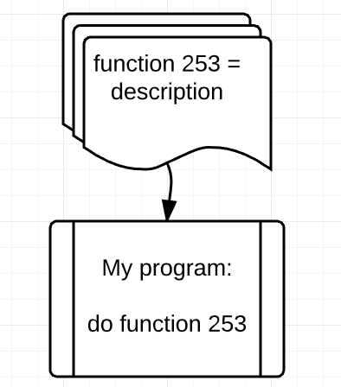Level 2 shows how our mars explorer can be rotated. The idea is that in programming you will constantly learn about new fucntions. Every language has hundreds and hundreds fucntions. You may even try to learn them all, but by the time you finish new functions will be created.

That is to say that we will introduce quite a few functions in this game, too. They are only native for our game, and you cannot use the same functions in any other language or platform (except for “while” loops and “if” statements). This is, therefore, referred as to be our ‘library’ – a collection of functions. *See Figure 1 for further reference.* We do not push this concept any further in the game, but you will be required to contently learn more and more fucntions as they appear in the game.

Lastly, you can use loops (as any other function) a few times in the same program. Thus, Level 2 requires from you to have certain code duplication in order to complete the task.

Figure 1: An example of library